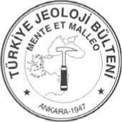

Türkiye Jeoloji Bülteni Cilt 54, Sayı 1-2, Nisan-Ağustos 2011
Geological Bulletin of Turkey Volume 54, Number 1-2, April-August 2011

Microfacies Analysis and Depositional Environments of Tertiary Carbonate
Sequences in Socotra Island, Yemen

Socotra Adasındaki Tersiyer Karbonat İstifinin Mikrofasiyes Analizi ve Çökel

Ortamları

Mohammed AL-WOSABI*, Ahmed AL-AYDRUS
Earth and Environmental Sciences Dept., Fac. Sci., Sana'a Univ., Yemen, PO. Box: 11903 Sana'a
(^Corresponding author, e-mail: ma_wosabi@yahoo.com)

ABSTRACT
A detailed study on the microfacies analysis and depositional environments of Tertiary sedimentary rocks exposed in Socotra Island were conducted. The investigation was based on fifty four samples collected from five stratigraphic sections and included four formations from base to top are Umm er Radhuma (Paleocene - Eocene), Dammam (Eocene), Aydim (Upper Eocene) and Mughsayl (Oligocene- Miocene). These rock units are mainly composed of carbonates. The petrographic study of unstained and stained thin sections have been carried out to investigate its sediment logy, microfacies associations and depositional environments. According to Dunham classification of limestone (1962), eight carbonate facies were distinguished. They are Mudstone, Dolomitic mudstone/wackestone, Fossiliferous wackestone, Packstone, Marly limestone, Sandy limestone, Reefal limestone, Brecciated wackestone/packstone and Chalky limestone. The recognized microfacies associations were correlated with the standard microfacies associations (SMA) which were supposed by Wilson (1975) and Flügel (1982 and 2005). The detailed microfacies analysis show that the studied rock units were deposited within the shallow marine environment except the upper parts of Mughsayl Formation, which were deposited in a slightly deep marine environment.
Key words: Tertiary carbonate, microfacies, paleoenvironments, Socotra Island, Yemen
ÖZ
Socotra adasında (Yemen) yüzlek veren Tersiyer yaşlı sedimanter kayaçların depolanma ortamları ve mikrofasiyes analizleri üstünde detaylı bir çalışma yapılmıştır. Araştırma beş stratigrafik kesitten toplanan elli dört örnek, ve alttan üste Umm er Radhuma (Paleosen-Eosen), Dammam (Eosen), Aydim (Üst Eosen) ve Mughsayl (Oligosen-Miyosen) olmak üzere dört formasyona dayandırılmıştır. Bu kayaçlar başlıca karbonatlardan oluşmaktadırlar. Boyanmamış ve boyanmış ince kesitlerin petrografik çalışması kayaçların sedimantolojilerini, mikrofasiyes birliklerini ve depolanma ortamlarını araştırmak için yürütülmüştür. Dunham (1962)'nin kireçtaşı sınıflamasına göre sekiz karbonat fasiyesi ayırtlanmıştır.
Bunlar çamurtaşı, dolomitik çamurtaşı/vaketaşı, fosilli vaketaşı, istiftaşı, marnlı kireçtaşı, kumlu kireçtaşı, resifal kireçtaşı, breşlemiş vaketaşı/istiftaşı ve tebeşirimsi kireçtaşıdır. Tanımlanan mikrofasiyes birlikleri Wilson (1975) ve Flügel (1982 ve 2005) tarafından önerilen standart mikrofasiyes birlikleriyle (SMB) ilişkilendirilmiştir. Detaylı mikrofasiyes analizleri çalışılan kayaçların Mughsayl formasyonunun az derin deniz ortamında depolanan üst kesimleri hariç sığ deniz ortamında çökeldiğinigöstermektedir.
Anahtar kelimeler: Tersiyer karbonat, mikrofasiyes, eski ortam, Socotra adası, Yemen

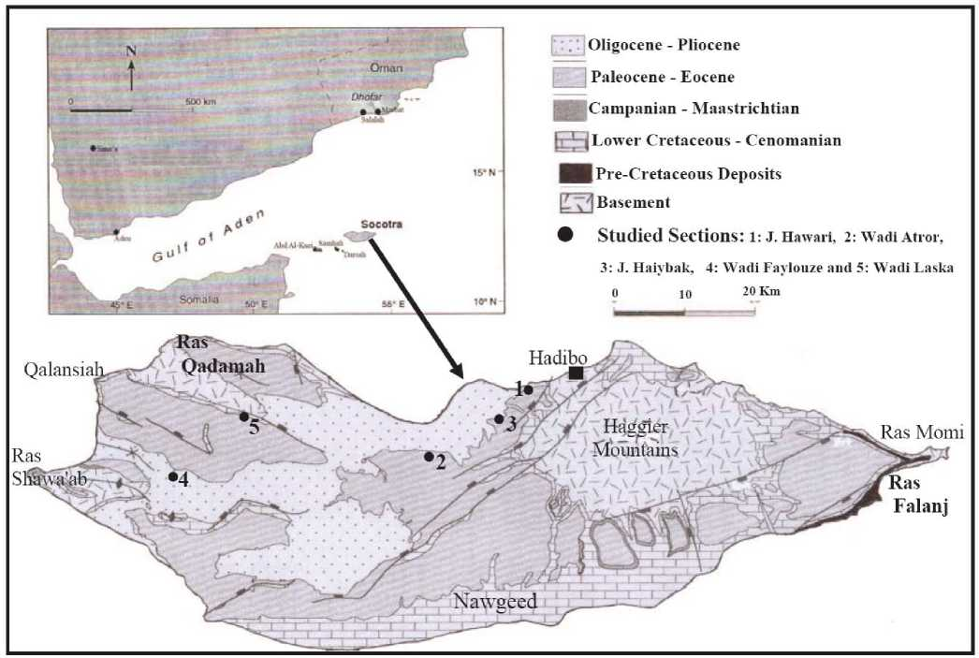
Figure 1. Geological map of Socotra Island showing the studied sectionsfAfter Morrison et al., 1997 with modification).

INTRODUCTION
Socotra archipelago in the Indian Ocean consists of four islands; these islands are Socotra, Abd Al-Kuri, Samhah and Darsa. Socotra Island represents the largest island in this archipelago; though the three small islands located at about 100km southwest of
the Socotra Island and form a chain reaches in its long to 150km (Fig.l). This Archipelago locates at the eastern limit of the Gulf of Aden and stay far from the Yemeni mainland about 360km and about 230km from the Horn of Africa (Fig.l).
Şekil 1. Socatra Adasındaki çalışılan kesitleri gösteren jeolojik harita (Morrison vd., 1997'den değiştirilerek).
To the north of the platform, the sea floor slopes steeply into the Gulf of Aden to depths greater than 2500m, within 20km of the islands (Fleitmann et al., 2004). The OligoMiocene oceanic crust lies to the north of the islands in water depth reaching in excess of 2500m (Laughton, 1966 and Laughton et al., 1970).
In spite of the geological studies in these Islands started at the nineteenth century, but they were rare due to their isolated locations. These studies were mentioned in Samuel et al. (1997) and included Bonny (1883), Raisin (1888), Sauer (1888), Gregory (1899), Kossmat (1907) and Pelikan (1907). The first detail geological study on the Socotra Island was carried out by Beydoun and Bichan (1970). As a result of the petroleum explorations, some detailed and specific geological studies appeared to give new new stratigraphic, sedimen-tological and geophysical information.
Birse et al. (1997), Morrison et al. (1997) and Samuel etal. (1997) have discussed the Mesozoic and Early Tertiary evolution, the Cretaceous sequence stratigraphy and the stratigraphic position of the Tertiary rocks in Socotra Platform within the exploration activities of some operating oil companies. As Saruri and Beydoun (1998) discussed the lithostratigraphic subdivision of the Shihr Group (Tertiary) in Yemen. Such researches have dealt with the stratigraphy and structural setting. However, the facies characteristics and paleoenvironments during Tertiary period have not been described or interpreted in detail.
The purpose of this paper is to define and analyze the microfacies of Tertiary carbonate rock units in Socotra Island and attempt to interpret the depositional environments which have been reflected the presence of those microfacies. The studied material includes 54 rock samples. They were collected from five exposed sections in Socotra Island. These sections are Jabal Hawari, Wadi Atror, Jabal Haiybak, Wadi Faylouze and Wadi Laska (Fig. 1). These samples are belonged to Paleocene, Eocene and Oligo-Miocene ages and represent the deposits of Umm er Radhuma, Dammam, Aydim and Mughsayl formations (Fig.2).
In general the carbonate rocks in Socotra Island are subjected to the dissolution due to the influence of semi-tropical climate (high temperature, heavy rains during the rainy seasons) and the moisture atmosphere; so many huge caves are formed such as Momi, Hoq and Thijob caves (Pl. I: a and b).

GEOLOGIC SETTING
Geology of Socotra was discussed in detail by Beydoun and Bichan (1970). They described the rock units of Socotra and the neighboring islands. In Socotra Island, The Haggler Mountains represent the largest basement blocks. These rocks outcropping also at Ras Shawa'ab, Qalansiah, Ras Qadamah and Ras Momi areas (Fig. 1). The age of the crystalline basement rocks was determined as 826 ± 41 Ma (Siebens, 1977).
The oldest sedimentary rocks refer to the Triassic age. These rocks unconformably overlying the peneplained basement rocks at Ras Falang and Ras Momi areas, with thickness reaches to 200m (Al-Wosabi and Wasel, 2010) (Fig. 2). These rocks consist of sandstone beds change gradationally from basal sandstone through upon limestone and marls up into a variety of purer carbonate facies (Samuel et al., 1997). Banner et al., 1997 dated these carbonate rocks as Toarcian - Bajocian age based on the recorded foraminiferal species.

Figure 2. General Stratigraphic chart of Socotra Island (modified after Samuel et al., 1997; Birse et al., 1997; Fleitmann et al., 2004; Al-Wosabi and Wasel, 2010).
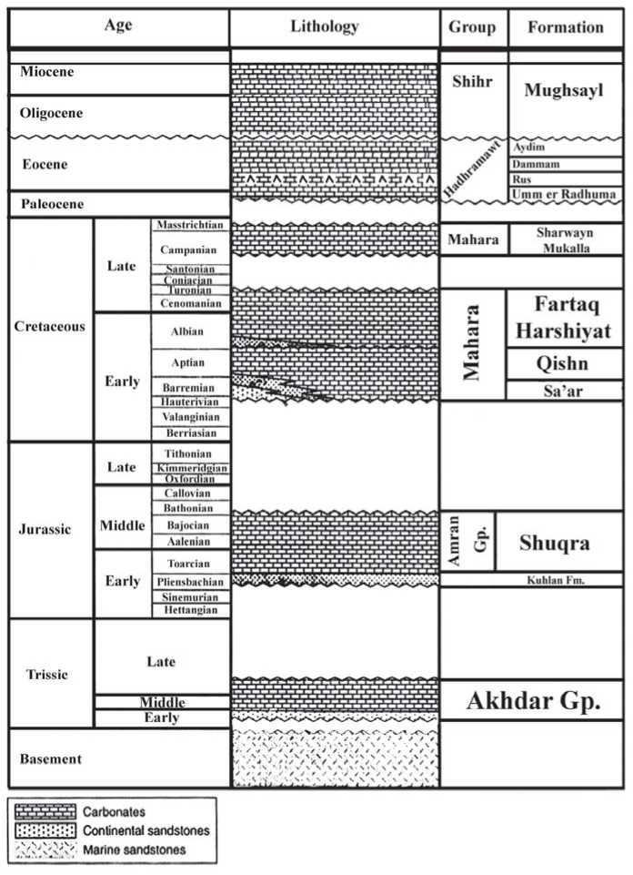

Şekil 2. Socotra Adasi'nrn genelleştirilmiş stratigrafik kesiti (Samuel vd., 1997; Birse vd. 1997; Fleitmann vd., 2004; Al-Wosabi and Wasel, 2010'dan değiştirilerek).

The deposits of the Early Cretaceous to Cenomanian (Qishn Formation) rest on the basement rocks unconformably in different areas of Socotra Island particularly in the Nawgeed area at the south (Figs. 1 and 2). A marked age break is apparent between the Cenomanian carbonate beds and overlain distinctive 10m unit of nodular planktonic foraminiferal limestone refer to the Campanian. The Campanian and Maastrichtian deposits are occurred only over two areas in Socotra Island and marked change in facies and depositional regime (Birse et al., 1997). These deposits comprise the interbeded limestones and shales of the Mukalla Formation and the more argillaceous limestone and claystones of Sharwayn Formation (Fig. 2) (Morrison etal., 1997).
The Paleocene - Eocene deposits in Socotra overlay the Cretaceous strata (Samuel et al., 1997). The contact between Cretaceous carbonate rocks and overlaying Paleocene rocks in Socotra is hard to determine in the field, but it is clear in Ras Shawa'ab that it is represented by an angular unconformity contact (Beydoun and Bichan, 1970 and Samuel et al., 1997). The carbonate rocks of Paleocene belongs to the Hadhramawt Group (Umm er Radhuma, Dammam and Aydim Formations) (Fig. 2). The late Oligocene to Early Miocene rocks is largely restricted to western Socotra. The Oligo-Miocene successions in Socotra Island rest unconformably over the basement crystalline rocks and reach to 65m in Qalansiah area. In general these rocks dominate by chalky bedded limestone, reefal limestone as well as packstone and wackestone facies. These rocks belong to Shihr Group (Mughsayl Formation) (Fig. 2).

LITHOSTRATIGRAPHY
Lithostratigraphy of Socotra Island not discussed in detail, but Beydoun and Bichan, 1970 have introduced an initial subdivision for the rock units of the island. Beydoun et al., 1998 constructed comparisons of some rock units in the Yemeni lands with their counterparts in Socotran platform relying based on Beydoun and Bichan, 1970; therefore the Lithostratigraphic subdivision of rock units in Socotran platform needs to great efforts for revising and introducing according to the Stratigraphic rules.
Tertiary carbonate rocks are widely spread in Yemen and the neighboring regions such as Somalia, Oman, Saudi Arabia, Iraq and Iran. Many researchers studied the stratigraphy of these rocks such as Abu Zeid and Boukhary, 1984; Hasson, 1985; Beydoun, 1991; Roger etal., 1992; Jones and Racy, 1994; White, 1994; Langbein and As Saruri, 1998; Polis et al., 2005; Al-Husseini et al., 2010 and Al-Wosabi et al., 2011.
The present work is related with the Tertiary carbonate rocks in Socotra Island. These units including Umm er Radhuma, Dammam, Aydim and Mughsayl formations. The first three formations belong to Hadhramawt Group and dated as Paleocene - Eocene, while the latter follows the Shihr Group and dated as Oligocene-Miocene (Fig. 2).
Umm er Radhuma Formation: This Formation was introduced by Sander, 1952 in unpublished doctoral thesis (Beydoun et al., 1998). The rocks of this formation are widely spread in the Arabian Peninsula and Iraq. It can be correlated with the similar rock units in the neighboring areas such as Somalilands Auradu Series) and Iran (Aaliji, Pabdeh and Jahrum Formations) (Fig. 3). In Yemen this rock unit represents the main Tertiary rock unit in the eastern part of the country. It consists mainly of massive limestone, dolomitic limestone, Marly limestone and some shales especially at the base of the formation. In Yemeni lands, this formation is conformably underlain and overlain by the Mukalla Formation and the basal shale of Jiza' Formation respectively. The age of this formation is considered as late Paleocene - Early Eocene.
In Socotra Island, Umm er Radhuma Fm. rests directly on the basement, but in Ras Shawa'ab it overlies the Cretaceous rocks by an angular unconformity; while it conformably underlies the Rus Formation.
Dammam Formation: This rock units was suggested by Bramkamp (1941) in
unpublished report to describe the shallow water shelf carbonates interbedded with marly limestone beds in the eastern parts of Saudi Arabia. Dammam Fm. is widely spread throughout the Arabian Peninsula and Iraq and can be correlated with the equivalent rock units such as Karkar Series in Somalilands and Jaddala and Jahrum Formations in Iran (Fig. 3). Samuel et al., 1997 used the name "Dammam" to describe the carbonate rocks in Socotra Island, which rest conformably on the Rus Formation and conformably underlain the Aydim Formation. The age of this rock unit is Middle-UpperEocene (Boukhary et al., 2005).
Aydim Formation: The Aydim Formation was introduced by Platel et al., 1987 to describe the upper Eocene limestone in Aydim area, Dhufar, Sultanate of Oman. The age of this rock unit is Late Eocene (Jones and Racey, 1994 and Racey, 1994). Aydim Formation consists mainly of different types of limestone (Marly limestone, mudstones and fossiliferous limestone). This formation occurs in eastern parts of Socotra and mainly consists of marly limestone, mudstone and fossiliferous wacke/packstone facies. This rock unit can be correlated with Karkar Formation ofSomalia (Fig. 3).
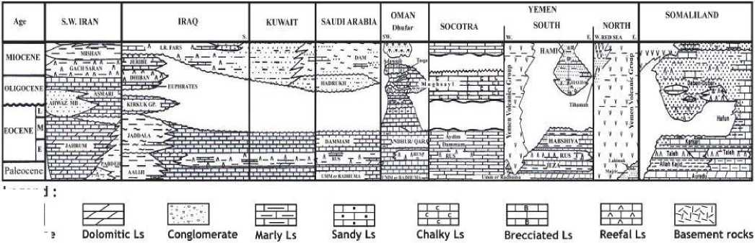
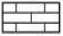
Mughsayl Formation: It was introduced by Platel et al., 1987 to describe the Oligocene-Miocene calcareous turbidites which filled the narrow down-faulted coastal basin in Raysut beach, Dhufar area, Sultanate of Oman. In Socotra Island, this formation is outcropping in the west areas around Qalansiah region. It unconformably overlies the Paleocene-Eocene rocks in the western parts of Socotra and conformably covered by the Quaternary deposits. In the southern parts of Yemen, this formation may be compared with the Hami Formation of the Mukalla- Sayhut Oligocene-Neogene basin (Fig. 3). Mughsayl Formation can be correlated with the equivalent rock units in neighboring regions such as Dagan Debar, Mughsayl Fm, Hadrukh Fm, Asmari Limestone and Euphrates, Dhiban and Jeribe Formations in Somalila, Oman, Saudi Arabia, Iran and Iraq, respectively (Fig. 3).
1991).
Şekil 3. Socotra Adası ve civarındaki bölgelerde çalışılan kaya birimlerinin karşılaştırılması (Beydoun,1991'den sonra).
Legend
Figure 3. Correlation of the studied rock units in Socotra Island and neighbouring regions (After Beydoun,
Limestone

FACIES ASSOCIATIONS AND ENVIRONMENTS
Thin sections of the collected samples were prepared and stained to examine and differentiate between the carbonate minerals in the Tertiary rocks. Studying these thin sections is carried out to detect the microfacies and then interpretthe paleoenvironments.
The adopted classification here is that proposed by Dunham (1962), which is based on the original depositional texture of carbonate rocks. Facies that are defined as well as the depositional environments in each formation will be displayed based on Wilson, 1975.
- UMM ER RADHUMA FORMATION
The Umm er Radhuma Fm. is outcropping in vast areas of the Socotra Island (Fig. 1J. The outcrops of this formation represent its upper part which was dated as late Paleocene age - Early Eocene (Fig. 2'). In this study, samples were collected from Jabal Hawari (12° 39' 59” N, 54° 03' 59” E) and Wadi Atror area (12° 30' 22” N, 53° 41' 23” EJ (Pl. I: c and d and figs. 4 and 5J. The thickness of these sections is 45m and 127m at J. Hawari and W. Atror respectively. Four microfacies were identified and described as follows:
- Mudstone Microfacies
This facies distributed through different levels in the studied sections. It mediated the Hawari section with a considered thickness up to 13m, where it is distributed in W. Atror section in many levels with a different thickness (Figs. 4 and 5J. Lime mudstone microfacies in Um er Radhuma Formation is characterized in outcrops by its light gray and yellowish color and moderately hard. Petrographically, It shows a high percentage of mud reach to 97% and rare present of benthic foraminifera and some skeletal debris (Pl. I: e and f).
The lime-mudstones facies have been deposited in a nearshore restricted lagoon of a rimmed carbonate shelfunder quiet water, shallow depth and poor circulation as evidenced from the fine-grained nature of their sediments and the type as well as very low diversity of the faunas. According to Wilson, 1975, this microfacies can be compared with the Standard Microfacies (SMFJ No. 22, which were deposited in the facies zone No.8. "restricted platform" (Figs. 4 and 5J.
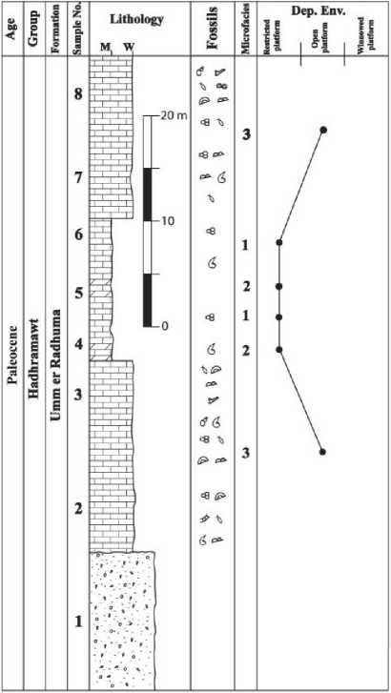
Figure 4. Lithologic log, microfacies association and distribution of depositional environments of Umm er Radhuma formation atjabal Hawari.

Şekil 4. Jabal Hawari'deki Umm er Radhuma formasyonunun litolojik logu, mikrofasiyes topluluğu ve çökel ortamının dağılımı.

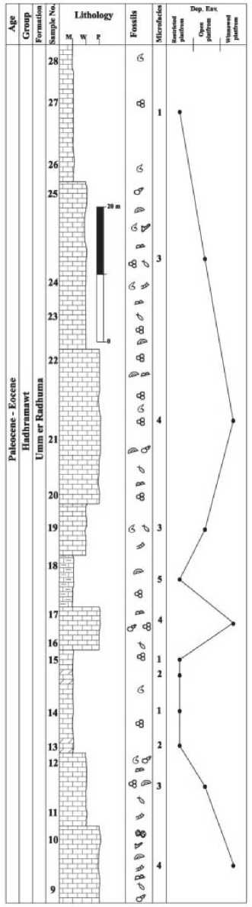
Şekil 5. Wadi Atror'daki Umm er Radhuma formasyonunun litolojik logu, mikrofasiyes topluluğu ve çökel ortamının dağılımı.
Figure 5. Lithologic log, microfacies association and distribution of depositional environments of Umm er Radhuma formation atWadi Atror.
- Dolomitic Fossiliferous Mudstone/ Wackestone Microfacies
This facies is not a common microfacies in the Umm er Radhuma sequence of Socotra Island. It was restricted in some levels of the studied sections (Figs. 4 and 5). In outcrops, these rocks are brownish to reddish, moderately to solid hard. It mainly composed of fine to medium grained bioclasts embedded in micritic matrix. Grains are moderately sorted and not oriented. Micrite is recrystallized into sparry calcite and sparite. Fine to medium grained dolomite rhombs scatter in the sample indicating non selective dolomitization with presence of some skeletal grains such as foraminiferal tests (Pl. I: g and h). This facies yields a few scattered debris of bivalve, echinoid and gastropod (Figs. 4 and 5). Mixing of the ground water with the marine water at this early depositional stage may explain the close association of the dolomite rhombs with the wackestone facies. Mudstones have been accumulated in an open lagoon regime developed on a rimmed carbonate shelf. The deposition took place in shallow waters with average depth of about 5-10 m, above normal wave base. The presence and diversity of the carbonate grains together with the presence of skeletal debris reflect deposition under normal marine salinity, moderately to quite agitated conditions. According to Wilson 1975, it is possible to compare with the standard microfacies 19 which were deposited within the facies zone 8 shelf restricted circulated platform (Figs. 4 and 5).
- Fossiliferous Wackestone Microfacies
The fossiliferous wackestones are the most abundant microfacies type in the Umm er Radhuma Fm in the studied sections (Figs. 4 and 5). It is distributed in different levels with a grain percentage reach to 30% in mud material. The rocks of this facies are yellowish to brownish

color, consolidated, coarse to medium grained. The fossiliferous wackestones are characterized by the presence of diverse faunal assemblages of bivalve, echinoderm, coralline algae, gastropod, foraminifera, ostracoda and bryozoa. They range in size up to several millimeters. Skeletal debris of bivalve and echinoderm are the most prominent skeletal particles. Foraminiferal assemblages are represented by Textulariina, Miliolina and larger forams such as Nummulites spp., Lacazina sp. cf. blumenthali Richel and Sigal and Daviesina khatiahi Smout (Pl II: a, b, c and d). Deposition of this microfacies took place under moderately agitated water conditions, above fair weather wave base. Fair circulation is also confirmed by the increasing ratio of echinoderm and benthic in the sediments.
Based on Wilson, 1975, Flügel, 1982 and 2004, The fossiliferous wackestones can be compared with the SMF no. 18, which was deposited in the facies zone No. 8 in restricted platform belt (Figs. 4 and 5).
- Packstone Microfacies
Packstone microfacies are represented in the studied sections of Umm er Radhuma Fm at several levels in Wadi Atror area. They are usuallythickbedded (5-12m) (Fig. 5).
Petrographically, two different packstone classes are distinguished based on the percentage of skeletal particles and allochems; they are foraminiferal packstone and peloidal bioclastic packstone. The recorded skeletal particles are bivalves, echinoids and different foraminiferal forms such as Alveolina, Saudella and Lockhartia species (Pl. II: e and f). Bivalve shell fragments are the most common. Some of these fragments are dissolved and their moulds are filled with sparite and micritic matrix. Other remains are neomorphosed to calcite spar or completely micritized to lime-mud. Echinoidal plates are distinguished as single crystals with uniform interference colors and locally rimmed by syntaxial calcite overgrowth. Echinoid spines are recognized by their radial structure. Benthonic foraminifera are represented by different foraminiferal species. Non-skeletal particles are mostly represented by pellets and few ooid grains (Pl. II: g). All components are jointed together by granular sparry calcite cement.
The depositional realm of packstone facies was restricted shelf lagoons when skeletal debris were derived from nearby shoal areas or reefs to shallow environment. The presence of broken skeletal components and planar beddings reflect high tidal currents and wave activity. This facies was formed in the facies zone No. 6 and correlated with the SMF No. 12 of Wilson, 1975 (Fig.5).
- DAMMAM FORMATION
Dammam Formation is distinguished in many areas of Socotra Island lying above the Umm er Radhuma rocks. It represents the lower Eocene age in the island. Samples were collected from Jabal Haiybak (12° 38' 06”N, 53° 57' 04”) (Pl. II: h and Figs. 1, 2 and 6). The following microfacies were identified.
- Marly Limestone Facies
This facies is recorded in the lower and upper horizons in Dammam Formation at Jabal Haiybak section (Fig. 6). It made up of clastic and carbonate materials which including skeletal grains distributed in micritic matrix. These rocks of this microfacies tend to be friable to semiconsolidated, green to pale grey color with a thickness reaches to 10m (Pl. Ill: a). The invertebrate fossils are lagoonal fauna including foraminiferal tests, bivalves, ostracods and gastropods. Skeletal grains are scattered and poorly sorted. Foraminiferal tests consist mostly oftextulariines and Milioloides (Pl. Ill: b and c).
Comparing this facies with those which proposed by Wilson, 1975, it similar to the SMF No.22 which was deposited in a quiet closed, low energy, protected low intertidal flat reward of a shallow marine lagoon within the facies zone No. 8 "restricted platform" (Fig. 6).
- Sandy Limestone Microfacies
This facies is of rather restricted and narrow extension. It onlaps and pinch out on the lower Eocene marly limestone in Jabal Haiybak. It composed of about 2.5m, brownish to yellow color sandy limestone. Locally it consists of scattered medium to coarse sub-angular to subrounded, badly sorted quartz grains embedded in lime mud (Pl. Ill: d). The physical properties of quartz grains reflect relatively short transported distance.
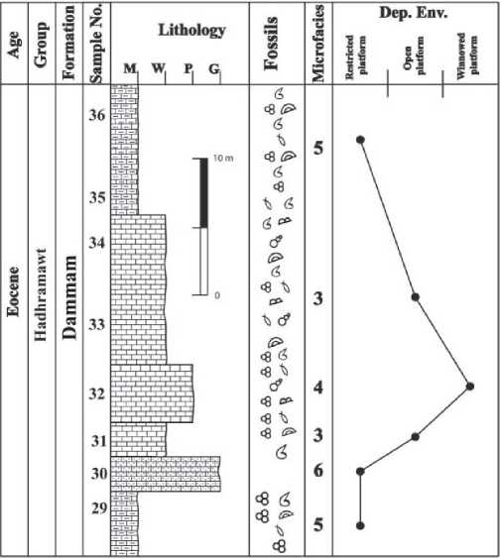
Figure 6. Lithologic log, microfacies association and distribution of depositional environ-ments of Dammam formation atjabal Haiybak.

Şekil 6. Jabal Haiybak'daki Umm er Dammam formasyonunun litolojik logu, mikrofasiyes topluluğu ve çökel ortamının dağılımı.
The deposition occurred during a period of steady sediment supply to the beach by a drainage system originated under moderate to high tidal range within the restricted platform in areas of large supply of detritus and high tidal currents. The mobility of the substrate in this high energy generally prevents faunal colonization and this explains the absence of fossil remains in this facies.
- Fossiliferous Wackestone Microfacies
This facies is mainly composed of fine to coarse grained bioclasts embedded in micritic matrix. Grains are not oriented and porosity is low. The Fossiliferous wackestones microfacies are most abundant in Dammam Fm and they are recorded from different horizons of the studied section (Fig. 6). These rocks are brown and moderately hard. Recognizable faunas are present and embedded in a high percentage of micrite matrix reach to 75%. Skeletal debris, with the exception of the calcitic are leached probably by meteoric groundwater forming mould cavities. The mould cavities are infilled by drusy calcite with crystal size increases away from cavity wall. The foraminiferal assemblage is dominated by Textularia sp., Triloculina sp. and Alveolina sp. (Pl. Ill: e, f and g). The matrix between grains is lime mud which is partially stained with iron-oxide spots and patches.
This facies is characterized by the presence of diverse faunal assemblages of gastropods, foraminifera and ostracods and a considerable amount of broken shells. This facies was deposited within the restricted platform belt "facies zone No. 8" of Wilson 1975 and similar to the SMF No. 18. (Fig. 6).
- Packstone Microfacies
This facies is rather restricted and narrow extension and it has been identified from the middle part of the Dammam Fm in the studied section. Foraminiferal packstone consists of a single layer of massive limestone that is up to 10 meters thick and is characterized by whitish to pale yellow color. It is composed of coarse to fine-grained bioclasts embedded in a microsparry calcite and some patches of micrit. Large foraminifera such as Nummulites spp are the main type of the represented bioclasts (Pl. IV: a and b). Grains are poorly sorted, disoriented with grain contacts. The micritic matrix sometimes recrystallized into sparite. Some cavities are distinguished. The most common megafossils are bivalves, echinoids, and gastropods.
The deposition of this facies took place under high energy conditions capable of moving and abrading the shell debris as evidenced from the grain-supported fabric of the rocks and the bioclastic nature of their skeletal particles. The breakage of the skeletal particles was accompanied by biogenic activity. The incorporated lime mud in this facies may suggest a high production rate of fine material by biogenic activity and faunal disintegration. According to Wilson 1975, the fossiliferous packstone microfacies here is resembling the standard microfacies No. 12 which was deposited within the facies zone No. 6 "Open platform" (Fig. 6).
- AYDIM FORMATION
The Aydim Formation in Socotra Island exposed in different parts of the island and represents the top part of the Hadhramawt Group in the island. Representative samples have been collected from a sequence of the Aydim Formation in Wadi Laska area (12° 35' 56” N, 53° 42' 05” E) (Pl. IV: c and Figs. 1, 2 and 7). Four microfacies were distinguished from this rock unit at the studied section.
- Marly Limestone Facies
This facies is recorded in the lower horizons in the studied section of the Aydim Formation (Fig. 7). Marly limestone facies consists of clastic and carbonate materials. The clastic materials accounted for up 45% of the total volume of the rock. Different types of invertebrate fossils distributed in this facies such as foraminifera, bivalves, gastropods, echinoids and ostracods as well as skeletal debris. Parts of this facies tend to be fragmented and semi-consolidated, green to pale grey color with a thickness reaches to 6 meters. Fossils are distributed through the facies and scattered in poorly sorted manner. This facies can be compared with the standard microfacies of Wilson, 1975 which was deposited within the facies zone no. 8 within the low energy protected low intertidal flat.
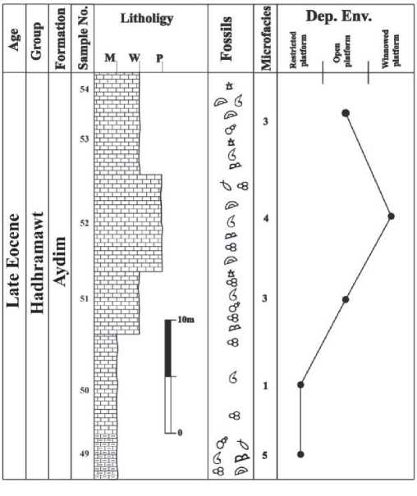
Figure 7. Lithologic log, microfacies association and distribution of depositional environ-ments of Aydim formation atWadi Laska.

Şekil 7. Wadi Laska'daki Aydim formasyonunun litolojik logu, mikrofasiyes topluluğu ve çökel ortamının dağılımı.
- Mudstone Microfacies
This microfacies is represented by yellowish grey/brown and hard limestones with thickness reaches to 8m. Petrographically, this facies consists of about 95% mud with the presence of some skeletal grains and debris being randomly scattered in the groundmass (Pl. IV: d).
The presence of high percentage mud with few allochems reflect quite energy, protected low intertidal flat which exists shoreward of a shallow marine lagoon, behind reef barriers or carbonate sand shoals. Based on Wilson 1975 and Flügel, 1982 and 2005, this facies is similar to the SMF No. 22, which is deposited within the facies zone No. 8 in the restricted platform area.
- Fossiliferous Wackestone Microfacies
This facies is recognized from two levels in Aydim Formation, the thickness in the lower horizon reaches to 5m, and about 10m in the upper level. Wackestone microfacies is characterized by its beige to brownish color, semi-hard and contains many invertebrate fossils embedded in lime mud matrix and consist about 25-30% from the all components such as gastropods, bivalves, echinoids, brachiopods, foraminifera such as Radiocycloclypeus stellatus (Tan) and Radiocycloclypeus sp. cf. radiates (Tan) and Nummulites sp. (Pl. IV: e and f) and shell debris (algal debris, bivalves and echinoids). The presence of broken skeletons of invertebrates refer to the deposition in a moderate agitated water within the restricted platform environment and it is similar to the standard microfacies No. 10 which is deposited within the facies zone No.7 (Fig. 7).
- Packstone Microfacies
This microfacies is recognized from the middle of the Aydim Formation in the study area with a thickness reaches to 10m. Different allochems were distinguished such as skeletal grains, intraclasts and some pellets. These allochems is cemented with sparry calcite and low percentage of micrite. The recorded skeletal particles are bivalves, benthic foraminifera, echinoids and ostracods. Bivalve shell fragments (up to 20%) are outlined by micrite envelopes and may reveal their internal microstrurcture. Occasionally, they are dissolved and their moulds are filled with granular sparite and micritic matrix. Other remains are neomorphosed to calcite spar or completely micritized to lime-mud. Echinoids are represented by plates and spines. Echinoid's plates are distinguished as single crystals with uniform interference colors and locally rimmed by syntaxial calcite overgrowth whereas echinoid spines are recognized by their radial structure. Gastropod and ostracode shells are found in less frequency and their cavities are filled with calcite spar and lime mud. Benthonic foraminifera are represented by micritic-walled miliolids, orbitolinids, alveolines, uniserial and biserial forms (Pl. IV:g).
This facies was formed in a high energy suite on shoals as indicated by shallow, warm and agitated water criteria. This facies can be compared with the standard microfacies No. 13 and which was deposited within the facies zone No. 6 in Wilson 1975 scheme (Fig. 7).
- MUGHSAYL FORMATION
Mughsayl Formation is exposed in several locations at the western parts of Socotra Island around Qalansiah region. This formation represents the Oligocene-Miocene limestone in this island. A carbonate section has been selected for sampling in Wadi Faylouze (12° 37^{z} 15” N, 53° 37^{z} 30” E) (Pl. V: a and b and figs. 1, 2 and 8). This section consists of about 70m of different limestone types, which is characterized by the presence of chalky limestone at the top part of this formation. This part is dominated by chert nodules in several horizons (Pl. V: c and d). Several microfacies are distinguished from this section, as follows:
- Reefal Limestone Facies
The reefal limestones form a dominant lithofacies type in the Mughsayl Formation. It is composed of massive-bedded with individual bed thickness reaching to 7.5m. They have Coral reef and oyster bivalve, which are the most common faunal assemblage. Scattered in situ coral reef patches and coral fragments are widely distributed throughout the succession to mark the reefal limestone facies (Fig. 8). Locally, foraminifers, algal fragments and echinoid represent an important sediment constituent (Pl. V: e). Densely crowded large foraminiferal tests are common in the upper part of this facies. The faunal assemblage is including some benthic foraminifers such as Heterostegina sp., Miogypsina sp., and Nummulites sp. among many other badly preserved forms (Pl. V: f, g and h).
Microscopically, the reefal limestones are dominated by the presence of boundstone textures which consist mainly of coral. This facies have been accumulated within the reef buildups platform margin zone under normal marine salinity and moderately conditions (Fig. 8).
- Brecciated Wackestone/Packstone Microfacies
These facies are common in the Mughsayl Formation (Fig. 8). They consist of alternating beds of packstone and wackestone in the middle horizon of the studied section. The rocks are brown to dark yellow, hard and contain scattered coarse limestone brecciated grains with different sizes (Pl. VI: a and b). These facies are characterized by the presence of different faunal assemblages with high abundance of skeletal debris. They are including bivalves, echinoids, ostracods and foraminifers. Bivalves were the almost components of invertebrate fossils in this facies. Beds of bioclastic wackestone/packstone which contain redeposited shelf debris (brecciated limestone and transported fauna) may interpret as calciturbidites. Samuel et al., 1997 mentioned that the alternating planktonic foraminiferal wackestone and bioclastic pack/wackestone in Mughsayl Fm at Socotra shows evidence of syn-rift deposition with a variety of chaotic deposits triggered by seismic activity and the steep slopes developed in the localized deep-marine basins.
Deposition of this facies took place under moderately agitated water conditions, above the wave base. Based on Wilson 1975, this facies can be compared with the standard microfacies No. 4, which is deposited within the facies zone No. 4 "foreslope area" (Fig. 8).
- Chalky Limestone Facies
Chalky limestone within this formation is a distinctive facies between the limestone facies in Socotra Island. It consists of about 7m of whitish to beige chalky limestone layers indulged by many dark grayish to dark brown nodules and pebbles of chert, which arranged in determined levels and in some horizons with randomly arrangements (Pl. V: c and d). In several horizons the chalky limestone beds characterized with slump structures (Pl. VI: c, d and e). Petrographically, this microfacies composed of lime mudstone contains planktonic foraminifera (Pl.VI: fandg).
Such facies was considered as exceptional pelagic sediments by Flügel, 2004. Based on Wilson, 1975, Flügel, 1982 and 2004, this facies is deposited in a deep environment withinthe facies zone No. 3 "basin margin zone".

Legend of Lithologic Sections
Lithology: Fossils:
eg Foraminlfera qq Corals
^{L}*7«°"^{e} d» Gastropoda Ostracoda
* J [ Blvalvws Sponges
Dolomitic Ls Basement rocks
I ] j 1 | do- F.ehinoidcs A Crinoids
Conglomerate Chalky Ls (J Skeletal debris M: Mudstone
1,2-11 1 1 I 1 1 Û Brachiopoda W: Wackestone
Marly Ls Brecciated Ls
■ i t i 1 Bryozoa p; Packestonc
Sandy Ls jf, Algae G: (.rainstone
Microfacies
1-Mudstone 2-l)olomitic fossiliferous mudstone / wackestone
3-Fossiliferous wackestonc 4-Packstone
5-Marly limestone 6-Sandy limestone
7-Reefal limestone 8-Brecciated wackestone / packestone
9-Chalky limestone

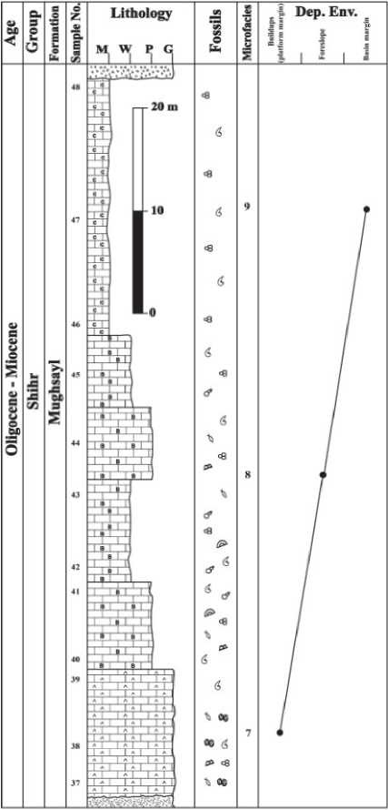

Şekil 8.Wadi Faylouze'deki Mughsaylformasyonunun litolojik logu, mikrofasiyes topluluğu ve çökel ortamının dağılımı.

CONCLUSION

Tertiary rocks in Socotra Island are attributable to five formations. These formations are Umm er Radhuma, Rus, Dammam, Aydim and Mughsayl. All these formations composed of carbonate rocks except Rus Formation, which consists mainly of evaporites, fieldwork supported by microfacies analysis has been enabled recognition of eight microfacies from the Tertiary carbonate rocks in Socotra Island. The identified microfacies of Hadhramawt Group are mudstone, wackestone, packstone and grainstone, while these differ completely for the Shihr Group in highlighting the presence of reefal limestone, brecciated limestone and chalky limestone. In all facies the allochemes consist mainly of skeletal grains in particular the larger foraminifera "exist in a warm water within the photic zone especially the upper 50m of warm seas", bivelves, gastropods and echinoderms, but in chalky limestone the allochemes consist of planktonic foraminifera "exist in deep marine". Actually, the types of facies and their contents reflect the environments and conditions of sedimentation. Facies of the formations belonging to Hadhramawt Group were deposited in between quite shallow environment (restricted platform) in case of marly limestone and mudstone facies and agitated shallow water (winnowed platform) for the packstone and grainstone facies. The wackestone facies was deposited in semi-quite shallow environment within the open platform zone. The Shihr Group is represented by Mughsayl Formation, which persists different facies such as brecciated limestone, reefal limestone and chalky limestone. These facies were deposited in organic buildup, foreslope and deep shelf margin zones respectively.
Studied Rock units were deposited during the Tertiary Period where the subjected areas as well as adjacent areas (Southern Oman, southwest and offshore of Iran, southern Iraq, the west coast of the Arabian Gulf and Southeast Somalia) were flooded with sea water in certain periods to precipitate limestone and when water retreated during other durations to produce evaporites. The latest Paleocene to Eocene was a period of renewed subsidence across the area "Socotra" and platform carbonates with a thickness over 700m are exposed in southern Socotra (Samuel etal., 1997). During this period (Ypresian and Bartonian), the deposition of Umm er Radhuma and Dammam Formations took place, but they separated by the deposition of the Rus Formation during a drop in sea level is consistent during Lutetian. In Middle-Late Eocene (Late Bartonian-Early Periabonian), the Aydim Formation was deposited due to transgression. During the Late Eocene (Late Periabonian) - Early Oligocene (Rubelian), Socotra Island exposed to erosion. Birse et al., 1997 mentioned that the tectonic regime altered during the Early Oligocene as one of differential uplift and erosion as is clearly recorded by the stratigraphic variations across the area. Beydoun and Bichan, 1970 emphasized that there is no record of any Upper Eocene deposits, and Socotra, in conformity with much of the adjacent Arabian and African regions appears to have been elevated about that time (Beydoun and Bichan, 1970). In the same age, drop in sea level is recorded in some parts of adjacent areas such as Jabal Hafit of the UAE by Cherif et al., 1992.

ACKNOWLEDGEMENTS
We would like to express our thanks to Engs. Abdullah Sua'idan and Hussien Mashdali form of the Geological Survey and Mineral Resources Board -Aden Branch - for the great cooperation during the sampling.
GENİŞLETİLMİŞ ÖZET
Socotra takımadası Hint Okyanusu'nda 150 km'lik bir zincir oluşturan dört adadan meydana gelmektedir. Aden Körfezi'nin doğusunda Yemen'den 360 km ve Afrika Boynuzu'ndan 230 km uzaklıkta bulunan bu adaların en büyüğü Socotra’dır (Şekil 1). İlk çalışmaların ondokuzuncu yüzyılda başlamasına rağmen, bu ada sistemi üzerine çalışmalar, izole konumlarından ötürü azdır, ve genellikle petrol şirketlerinin bazı raporlarıyla sınırlıdır. Bu çalışmada Socotra adasındaki Tersiyer yaşlı karbonat kayalarının depolanma ortamlarının yorumlanması için, mikrofasiyes özelliklerinin tanımlanmaları ve analizi amaçlanmıştır. Bunun için ise adadaki Paleosen, Eosen ve Oligo-Miyosen yaşlı birimlerde beş adet stratigrafik kesitten derlenen 54 adet örnek üzerinde çalışılmıştır.
Socotra adasındaki en yaşlı çökel birimler daha yaşlı kristal temel kayalar üzerine uyumsuzlukla gelen ve 200 m kalınlığa ulaşan Triyas yaşlı kayalarla temsil edilmektedir (Al-Wosabi ve Wasel, 2010). Bunlar, alt seviyelerde kumtaşlarmdan başlayan ve üste doğru karbonat bileşimi artan, en üstte ise saf karbonat fasiyeslerinden oluşan bir litolojiye sahiptirler (Samuel ve diğ., 1997). Triyas birimleri, benzeri bir istifsel özellik sunan ve içerdikleri foraminifer türlerine göre Alt-Orta Jura olarak yaşlandırılan çökellerce üzerlenirler. Bu birimin üstüne ise Alt Kretase'den başlayan ve Senomaniyen'e ulaşan yaşta karbonat kayaları gelmektedir. Karbonat kayaları genel olarak kireçtaşı ve şeyl ardalanmaları ile daha killi nitelikteki kireçtaşları ve kiltaşlarımn ardalanmasından oluşur (Şekil 2; Morrison ve diğ., 1997). Kretase birimleri Paleosen-Eosen çökellerince açısal uyumsuzlukla üzerlenmektedir (Samuel ve diğ., 1997). Bu birimlerde yine karbonatlı kayalardan oluşmaktadır. Çalışma konusunu oluşturan Oligo-Miyosen yaşlı birimler Socotra adasında kristalen temel kayalar ve diğer birimler üzerine uyumsuzlukla oturmakta ve Qalansiah bölgesinde 65 m'lik kalınlığa ulaşmaktadır. Genel olarak bu kayalar; tabakalı kireçtaşı, pakettaşı ve istiftaşı fasiyesinde resifal kireçtaşlarmdan oluşmaktadır.
Tersiyer yaşlı karbonat kayaları Yemen'de ve Somali, Umman, Suudi Arabistan, Irak ve İran gibi komşu bölgelerde de yaygındırlar. Socotra adasında bu birimler Umm er Radhuma, Dammam, Aydim ve Mughsayl formasyonlarından meydana gelmektedir. Bu formasyonlardan ilk üçü Hadhramawt Grubu'na ait olup Paleosen-Eosen olarak yaşlandırılırken, sonuncusu Shihr Grubu'na ait olup Oligo-Miyosen yaşlıdır (Şekil 2).
Hadhramawt Grubu'nda tanımlanan mikrofasiyesler çamurtaşı, vaketaşı, istiftaşı ve tanetaşmdan oluşmaktayken, bundan tamamen farklı olarak Shihr Grubu resifal kireçtaşı, breşleşmiş kireçtaşı ve tebeşirimsi kireç- taşmdan meydana gelmektedir. Tüm fasiyes- lerde başlıca allokemler iskelet parçalarıdır. Bu parçalar ise iri foraminiferlere, bivalvialara, gastropodlara ve ekinodermlere aittir. Bu mevcut türler "sıcak denizlerin özellikle üst 50 m'lik kısmında fotik zona” özgüdürler. Bunlardan farklı olarak tebeşirimsi kireçtaşı fasiyesinde "derin deniz ortamında" var olan planktonik foraminiferlerden oluşan allokemler vardır. Hadhramawt Grubu'na ait formasyonların fasiyesleri, marnlı kireçtaşı ve çamurtaşı fasiyeslerinin gösterdiği gibi sakin sığ bir ortamda (dar platform), ve istiftaşı ile tanetaşı fasiyeslerinin gösterdiği gibi de çalkantılı sığ su (ayıklanmış platform) ortamına işaret etmektedirler. Vaketaşı fasiyesi ise açık platform alanının yarı-sakin sığ ortamında depolanmıştır. Mughsayl formasyonundan oluşan Shihr Grubu ise breşleşmiş kireçtaşı, resifal kireçtaşı ve tebeşirimsi kireçtaşı gibi farklı fasiyeslerce oluşturulmaktadır. Bu fasiyesler ise sırasıyla, organik yığılma, yamaç önü ve derin şelf kenarı alanlarında depolanmışlardır.

REFERENCES
Abu Zeid, M. M. and Boukhary, M. A., 1984. Stratigraphy, Facies and Environment of Sedimentation of the Eocene Rocks in the Fahahil ('Gebel Dukhan) Section, Qatar, Arabian Gulf. Revue Paleobiol, 3, 73-159.
Al-Husseini, M. I., Mahmoud M. Dia and Matthews, R. K., 2010. Miocene Kareem Sequence, Gulf of Suez, Egypt. GeoArabia, 15 (2), 175-204.
Al-Wosabi, M. A. and Wasel, S., 2010. Lithostratigraphic subdivision of the Kuhlan Formation in Yemen. Arab J Geosci, DOI 10.1007/sl2517-010-0236-9.
Al-Wosabi, M. A., Khalifa, M. S. and Khaiwka, M. H., 2011. Application of graphic correlation technique on Paleocene- Early Eocene benthic foraminifera, Rub’ Al-Khali Basin and neighboring regions. Arab J Geosci, 4, 607-623.
As Saruri, M. L. and Beydoun, Z.R., 1998. Lithostratigraphic subdivision of the outcropping late Cenozoic Shihr Group, Republic of Yemen. Zeitschrift Fur Geologische Wissenschaften, 26 (5/6), 705-725.
Banner, F.T., Whittacker, J.E. and Boudagher-Fadel, M. K., 1997. Socotraina, a new hauriniid genus from the Upper Liassic of the Middle East (Foraminifera, Textulariina). Revue de Micropaleontologie40: 115-123.
Beydoun Z.R., 1991. Arabian Plate Hydrocarbon Geology and potential - A plate tectonic approach. AAPG studies in geology 33.
Beydoun, Z. R. and Bichan, H.R., 1970. The Geology of Socotra Island, Gulf of Aden. Quarterly Journal of the Royal Society ofLondon 125,413-446.
Beydoun, Z. R., As-Saruri, M., El-Nakhal, H., Al-Ganad, I., Baraba, R., Nani, A. and Al-Aawah, M., 1998. International Lexicon of Stratigraphy, Vol. II, Asia, Fascicule 10b2, Republic of Yemen. IUGS Publication, 34.
Birse, A.C.R., Bott, W.F., Morrison, J. and Samuel, M.A., 1997. The Mesozoic and Early Tertiary tectonic evolution of the Socotra area, eastern Gulf of Aden, Yemen. Marine and Petroleum Geology, 14 (6), 675-684.
Bonny, T. G., 1883. On a collection of rock specimens from the island of Socotra. Philosophical Transactions of the Royal Society ofLondon, 174, 273-294.
Boukhary, M., Abdelghany, 0., Bahr, S. and Kame, Y, 2005. Upper Eocene larger foraminifera from the Dammam Formation in the border region of United Arab Emirates and Oman. Micropaleontology, 51 (6), 487-504.
Bramkamp, R. A., 1941. Geological description of the Qatar Peninsula. Department of Petroleum Affairs, Qatar (Unpublished).
Cherif, O. H., Al-Rifaiy, I. A. and El-Deeb, W. Z. M., 1992. “PostNappes” early Tertiary foraminiferal paleoecology of the northern Hafit area, south of Al-Ain City (United Arab Emirates). Micropaleontology, 38, 37-56.
Dunham, R. J., 1962. Classification of Carbonate rocks according to depositional texture. AAPG. Mem. 1,180-121.
Fleitmann, D., Matter, A., Burns, S. J., Al-Subbary, A. and Al- Aowah, M., 2004. Geology and Quaternary climate history on Socotra. Fauna of Arabia, 20, 27-43.
Flügel, E., 1982. Micofacies Analysis of limestone. SpringerVerlag Berlin.
Flügel, E., 2005. Micofacies of Carbonate rocks, Analysis, Interpretationand Application. Springer-Verlag, Berlin.
Gregory, J.W., 1899. A note on the geology of Socotra and Abd- el-Kuri. Geological Magazine (N.S.) Decade IV (6), 529-533.
Hasson, P.F., 1985. New observations on the biostratigraphy of the Saudi Arabian Umm er Radhuma Formation (Paleogene) and its correlation with neighboring regions. Micropaleontology, 13 (4), 335-364.
Jones, R.W. and Racy, A., 1994. Cenozoic Stratigraphy of the Arabian Peninsula and Gulf. Micropaleontology and Hydrocarbon Exploration in the Middle East. Edited by M.D. Simmons, Chapman &Hall, 273-307.
Kossmat, F., 1907. Geologi der Inseln Sokotra, Semha, und Abd- el-Kuri. Denkschriften der Kaiserlichen Akademic der Wissenshaften in Wien. Mathematisch- naturwissenschaftliche Klasse, 71 (1), 1-62.
Langbein, Von Rolf and As-Saruri M.L., 1998. Die Rus Formation (Untres Eozân) auf der südlichen Arabischen Halibinsel. Zeitschrift Fur Geologische Wissenschaften, 26 (5/6), 673682.
Laughton, A.S., 1966. The Gulf of Aden. Phil. Trans. R. Soc. London,A259,150-171.
Laughton, A.S., Whitmarsh, R.B. and Jones, M.t., 1970. The evolution of the Gulf of Aden. Phil. Trans. R. Soc. London, A267, 227-266.
Morrison, J., Birse, A., Samuel, M.A., Richardson, S.M., Harbury, N. and Bott, W.F., 1997. The Cretaceous sequence stratigraphy ofthe Socotran platform, the Republic ofYemen. Marine and Petroleum Geology, 14 (6), 685-699.
Pelikan, A., 1907. Petrographische Untersuchungen von Gesteinen der Inseln Sokotra, Abd-el-Kuri und Semha. Denkschriften der Kaiserlichen Akademie der
Wissenshaften in Wien, Mathematisch-naturwissen- schaftliche Klasse, 71 (1), 63-91.
Platel, J.P., Berthiaux, A., Roger, J., Ferrand, A., 1987. Geological Map of Hawf, Sheet NE 39-16B, scale 1:100,000, with Explanatory Notes. Directorate General of Minerals, Oman Ministry of Petroleum and Minerals.
Polis, S. R., Angelich, M. T., Beeman, C, R., Maze, W. B., Reynolds, D. J., Steinhauff, D. M., Tudoran, A. and Wood, M. V., 2005. Preferential deposition and preservation of structurally- controlled synrift reservoirs: Northeast Red Sea and Gulf of Suez. GeoArabia, 10 (1), 97-124.
Racey, A., 1994. Palaeoenvironmental Significance of Larger Foraminiferal Biofabrics: Implications for Petroleum Exploration. AL-HUSSEINI, M.I. (ed.) Selected Middle East Papers fromAAPGGEO'94, Bahrain, 2, 793-810.
Raisin, C.A., 1888. On some rock specimen from Socotra. Geological Magazine (N.S.) Decade III, 5. 504-507.
Roger, J., Platel, J.P., Berthiaux, A., and Le Metour, J., 1992. Geological map of Hawf (Sheet NE 39-16, Scale 1:250 000). Ministry of Petroleum and Minerals, Directorte General of Minerals, Sultanate ofOman.
Samuel, M.A., Harbury, N., Bott, R. and Thabet, A.M., 1997. Field observations from Socotran platform: their interpretation and correlation to southern Oman. Marine and Petroleum Geology, 14 (6), 661-673.
Sauer, A., 1888. Ueber Riebeckit, ein neues Glied der Hornblendegruppe, sowie uber Neubildung von Albit in granitischen Orthoklasen. Zeitschrift der Deutschen geologischen Gesellshaft, 40, 138-146.
Siebens Oil and Gas Ltd., 1977. PDRY-Socotra Concession: Geological field trip to Socotra, Samha, and Abd al Kuri. Siebens Oil and Gas Company (Unpublished).
White, M. R., 1994. Foraminiferal biozonation of the northern Oman Tertiary carbonate succession. Micropaleontology and Hydrocarbon Exploration in the Middle East. Edited by M.D. Simmons, Chapman & Hall, 309-343.
Wilson, J. L., 1975. Carbonate facies in geologic history, Springer Verlag, Berlin.
MakaleGelişTarihi :19Mayis2011
KabulTarihi :14Ekim2011
Received : May 19th, 2011
Accepted : October 14th, 2011

PLATES
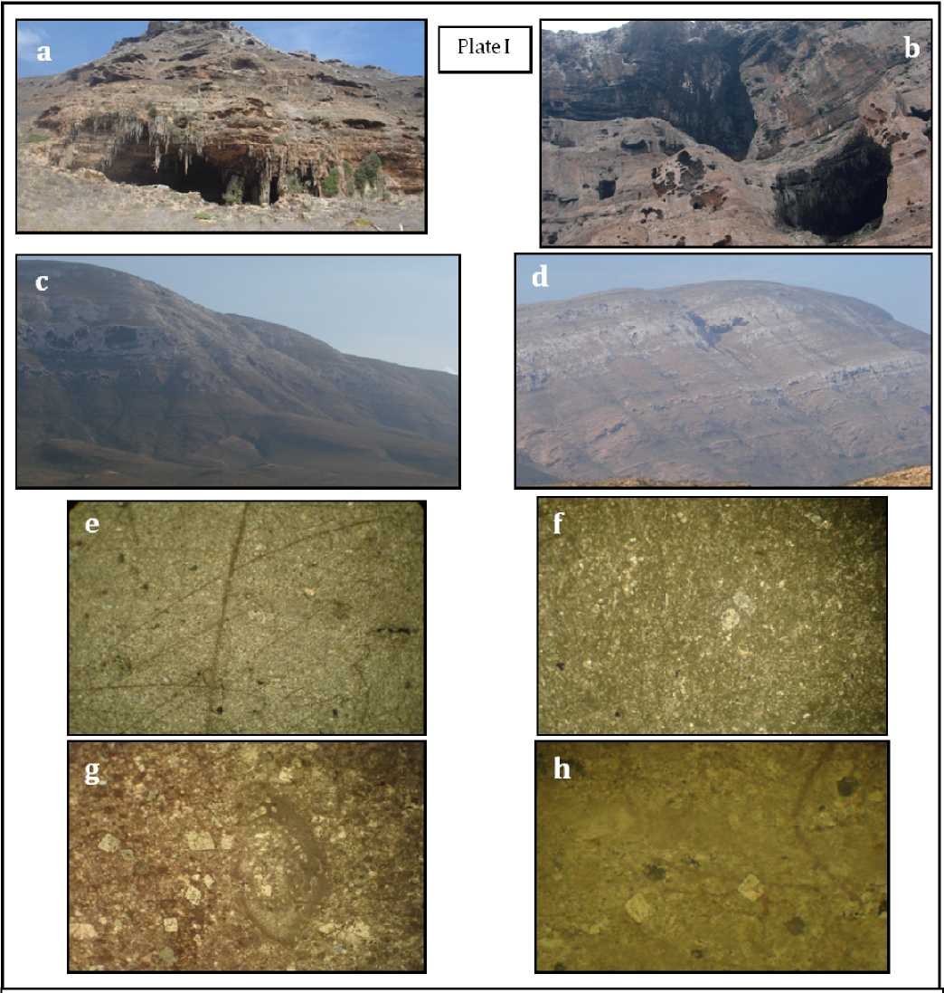
Plate I: a) Thi Jub cave at Nawgeed area, Socotra Island. b) caves within the carbonate rocks, Ras Momi area, Socotra Island. c) Studied section of Umm er Radhuma Formation at Jabal Hawari. d) Studied section of Umm er Radhuma Formation at Wadi Atror. e and f) Rare presence of benthic foraminifera and some skeletal debris in mudstone microfacies in Umm er Radhuma Fm. (X50). g) Foraminiferal test within the Dolomitic fossiliferous mudstone/wackestone microfacies of Umm er Radhuma Fm X 30. h) Scattered dolomite rhombs within the Dolomitic fossiliferous mudstone/wackestone microfacies of Umm er Radhuma Fm X 30.
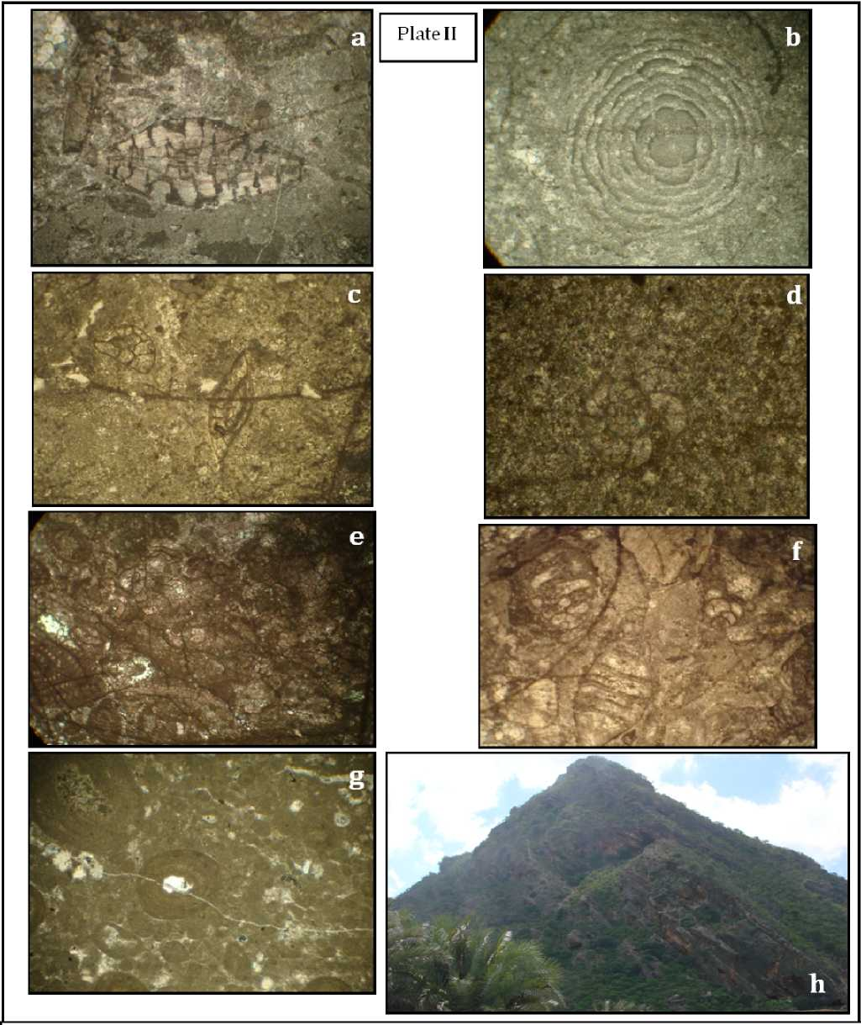

Plate II: a-d) Fossiliferous wackestone facies, Umm er Radhuma Fm. a: Nummulites sp. X 10. b) Lacazina sp cf blumenthali Richel and Sigal. X 30 c) Foraminiferal tests X 15. d) Daviesina khatiahi Smout. X 25. e-f) different foraminiferal species in Packstone microfacies, Umm er Radhuma Fm. X 10. g) Non-skeletal particles from Packstone microfacies, Umm er Radhuma Fm are mostly represented by pellets and few ooid grains. X 50. h) Studied section of Dammam Formation at Jabal Haiybak.

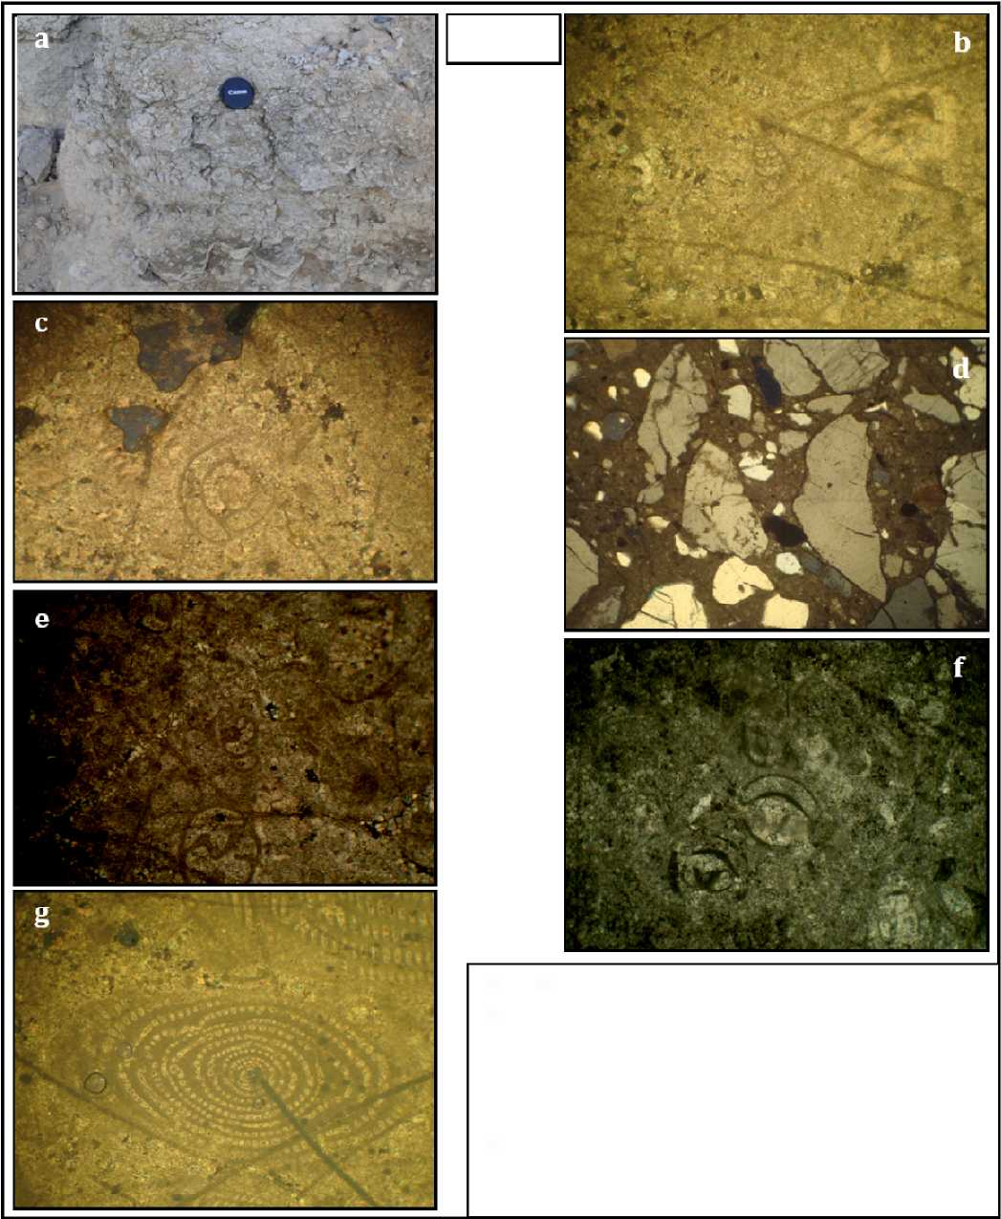
Plale III
Plate III: a) Marly limestone from Dammam Formation. b & c) textulariines and Milioloides from Marly limestone, Dammam Fm. X 50. d) Angular quartz grains in sandy ls microfacies, Dammam Fm. X 30. e -g) foraminiferal assemblage from fossiliferous wackestone microfacies, Dammam Fm., e: Textularia sp., f: Triloculina sp. X 50. g) Alveolina sp. X 10.

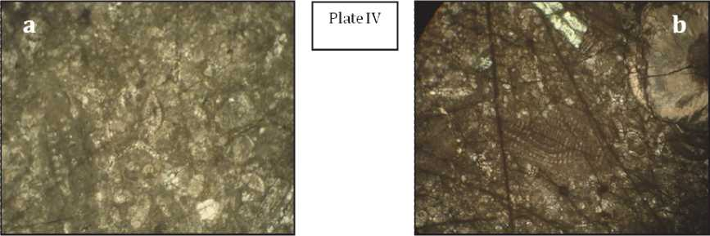
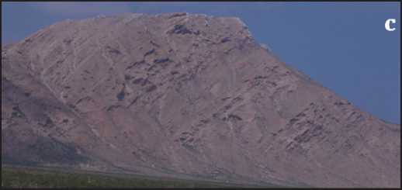
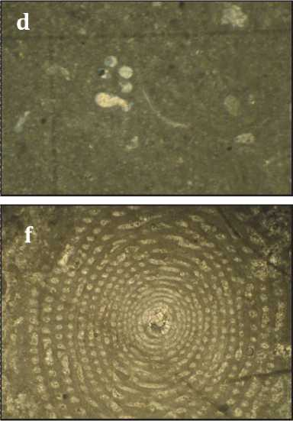
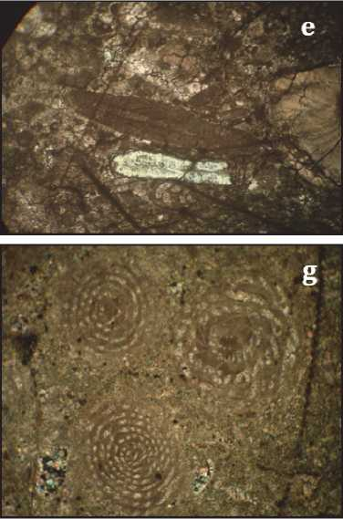

Plate IV: a) Different foraminiferal species, Packstone microfacies, Dammam Fm. X 20. b) Different foraminiferal species. Packstone microfacies, Dammam Fm. X 20. c) Studied section of the Aydim Formation at Wadi Laska area, d) Foraminiferal species embedded in mud, mudstone microfacies, Aydim Fm. X50. Fossiliferous wackestone inicrotacies, Mughsayl Fm. e) Radiocycloclypeus steliatus (Tan). Aydim Formation. X 15. and f) Radiocycloclypeus sp. cf. radiates (Tan). Aydim Formation. X 30. g) orbitolinids and alveolinid foraminifera, packstone microfacies, Aydim Fm. X 10.
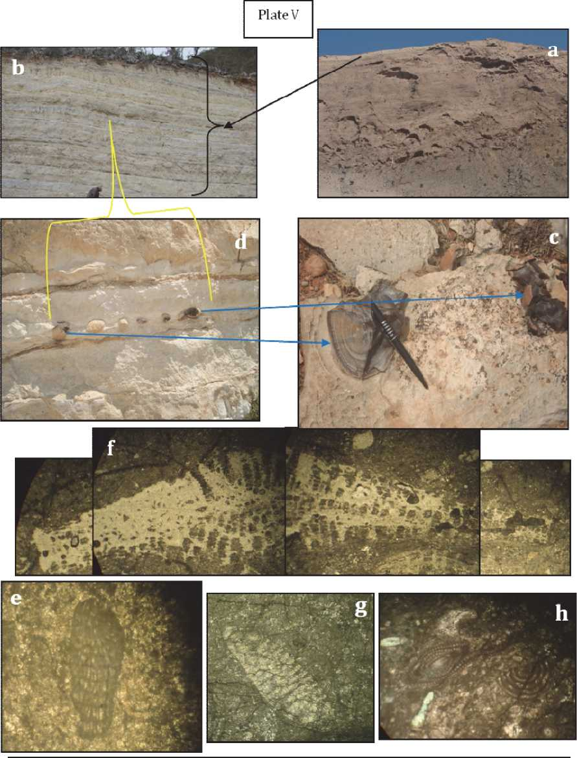

Plate V: a) Studied section of Mughsayl Formation at Wadi Faylouze area, b) Top part of Mughsayl Formation "chalky limestone", c and d; chert nodules in the chalky limestone, Mughsayl Formation, e) Algal fragment from reefal limestone, Mughsayl Formation. f-g) Foraminifeial species from the reefal limestone facies, Mughsayl Fm; f) Heterostegina sp. X 15. Miogypsina sp.X 15; h) Nummulitessp. And alveolinidforaminifera.X8.
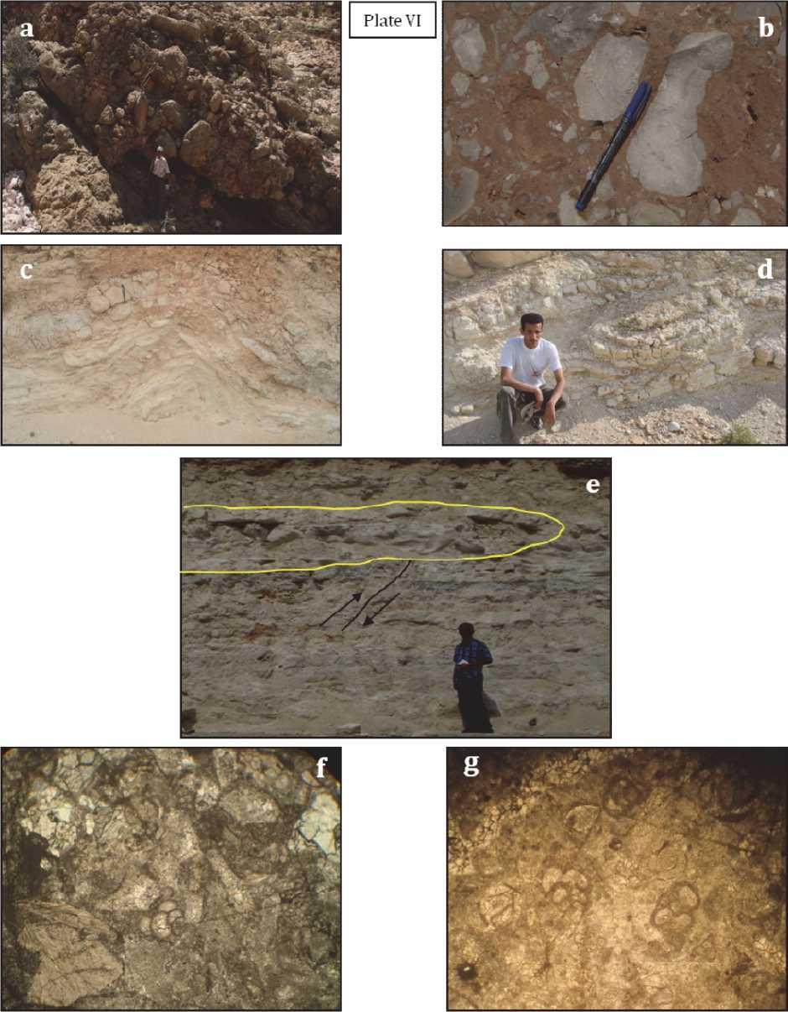

Plate VI: a-b) Brecciated limestone from Mughsayl Formation c-e) Slump structures from chalky limestone, Mughsayl Formation, f-g* Planktonic Foraminiferafrom chalky limestone, Mughsayl Formation.

