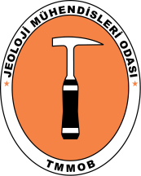 | Uluslararası Katılımlı 72. Türkiye Jeoloji Kurultayı  72nd Geological Congress of Turkey with international participation | 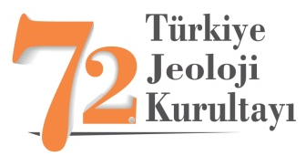

Abstract Title (Times New Roman, First Letter of the Words Capitalized, 12 pt, Centered, Bold)
Bildiri Başlığı (Times New Roman, her sözcük büyük harfle başlar, 12 pt, ortalanmış, italik)

Author Name Surname¹, Author Name Surname², (Times New Roman, 11 pt, centered, bold)
¹Address1 (Times New Roman, 10 pt, centered, italic)
²Address2 (Times New Roman, 10 pt, centered, italic)
(e-mail address of the corresponding author in parentheses, 10 pt, centered, italic)

Abstract (Times New Roman, 11 pt, bold, justify text): Participants must prepare an abstract for the 72nd Geological Congress of Turkey, in the style, layout and format in accordance with guidelines outlined here and in the conference website. As it is easier, it is highly recommended to use this page to prepare an abstracts.

The abstract not exceeding 300 words should be informative (aim of the study and main conclusive remarks) and also original. The abstract should be given in both Turkish and English. If the paper is written in Turkish, an English abstract (in italics) should follow the Turkish abstract, while a Turkish abstract (in italics) should appear after the English abstract in papers written in English. For non-Turkish participants Organizing Committee will provide assistance to translate abstracts to Turkish. Citations, reference lists, figures, tables, special symbols, headers and footers should be avoided. All authors are requested to avoid statements, which may cause potential conflict of interest with other people or organizations. The submission of an abstract has an obligation. It should actually be presented at the conference by the author or, at least, by one of the co-authors. The conveners reserve the right to accept or refuse contributions on the basis of the abstracts, if they do not meet guidelines outlined in this instruction. Each participant may submit up two abstracts in which they appear as a presenting author.

Keywords: Word 1, Word 2, … The abstract should include at least 2, and at most 7 key words which reflect the entires which the authors would like to see in the index page. Key words should be given in both Turkish and English. Key words should be written in lower-case letters, separated by commas, and given in the alphabetical order.

Öz (Times New Roman, 11 pt, metni iki yana yasla, koyu): Türkiye Jeoloji Kurultayı’na sunulacak bildiri özlerinin bu örnekte verilen formata uygun şekilde hazırlanması istenmektedir. Özlerin doğrudan bu sayfanın üzerinden yazılmasının yazarlara kolaylık sağlayacağı hatırlatılır.

Özler, çalışma hakkında bilgi verici bir içerikle (çalışmanın amacı, elde edilen başlıca sonuçlar gibi), özgün ve 300 kelimeyi aşmayacak şekilde hem Türkçe, hem, İngilizce olarak verilmelidir. Türkçe hazırlanmış yazılarda “Öz”den sonra “Abstract” (İtalik) yer almalı, İngilizce yazılarda ise italik yazılmış Türkçe Öz, Absract’ı izlemelidir. Öz’de kaynaklara atıfta bulunulmamalı, şekil, çizelge ve kaynaklar dizini yer almamalıdır. İngilizce özler hatasız bir dille yazılmalı ve Türkçe özle uyumlu olmalıdır. Özlerde; kurgusal sonuçlar doğurabilecek ve kişi, kurum ve kuruluşları olumsuz yönde etkileyebilecek hususlara ve ifadelere yer verilmemesine özen gösterilmelidir. Bildiri özlerinin yukarıda belirtilen yazım kurallarını ve ilkeleri sağlamaması durumunda, oturum yürütücülerinin gönderilen özleri kabul etmeme hakları saklıdır. Aynı birinci yazarlardan gönderilecek olan ikiden fazla bildiri kabul edilmeyecektir.

Anahtar Kelimeler: Kelime 1, Kelime 2, … Öz ve Absract’ın altında 2-7 kelimeyi aşmayacak şekilde ve yazının konusun yansıtan anahtar kelimeler Türkçe ve İngilizce olarak verilmelidir. Anahtar kelimeler, alfabetik sırayla küçük harfle (ilk anahtar kelimenin ilk harfi büyük) yazılmalı ve aralarına virgül konulmalıdır.

INTRODUCTION

This proceedings template is an example of the final publication format for proceedings papers that will be published in the proceedings of the 72nd Geological Congress of Turkey with international participation, 28 January-01 February, 2019, Ankara, Turkey.

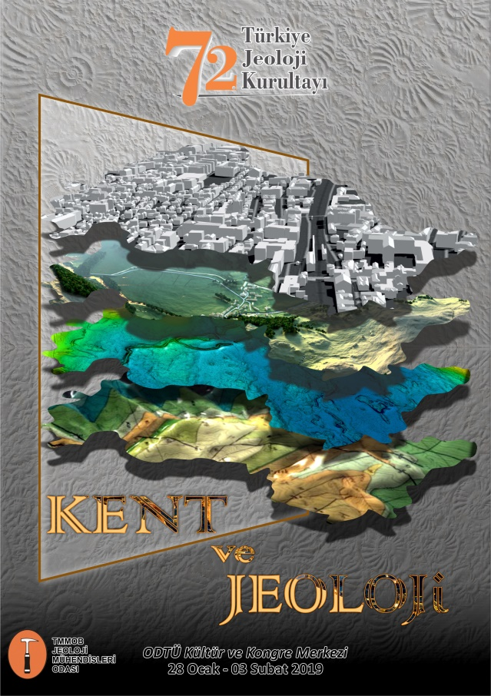
Figure 1. Captions appear related with the figures and with 11 pt sized. All figures must be referred to in the main text.

PRIMARY HEADING (TIMES NEW ROMAN, 11 PT, ALIGN TEXT LEFT, BOLD, UPPER CASE)

The various levels of headings used in the manuscript should be clearly differentiated. All headings should be in left-aligned. Major headings should be bold capitals. Secondary headings should be considered as sub-headings. Primary- and secondary-subheadings should be given in lower-case and tertiary headings in italics. Headings should not be preceded by numerals or letters.

Primary Sub-Heading (Times New Roman, 11 pt, align text left, bold, first letter of the words capitalized)

Mathematical symbols and formulas should be typed. Equation numbers should appear in parentheses at the right-hand side of the equations and be numbered consecutively. For Greek or other non-Roman letters, identify the symbol in words in the left-hand margin just below the equation the first time it is used. In addition, the meaning of symbols used in equations should be given below the equations.

“Where is the shear strength, c is cohesion, is normal stress and, is internal friction angle” Subscripts and superscripts should be given clearly and written in smaller character (e.g. I_{d}, x²). Instead of square-root symbol, an indice of 0.5 sholud be used (e.g. y=5^{0.5}). For the of multiplication sign do not use any symbol, however if necessary, the symbol “*” can be preferred (e.g. y=5*10⁻³). Please use “/” for division instead of a horizontal line between numerator and denominator. In the expression of chemical reactions, ions should be given as Ca²⁺ and CO3²⁻ (Ca⁺⁺ and CO3⁻⁻). In the text, equations should be referred to as equation⁽¹⁾. Computer program listings, if appropriate, must be very clear in an Appendix.

Secondary sub-heading (Times New Roman, 11 Pt, align text left, bold, lowercase)

Tables with their titles should not exceed the printed area of the page (15.8 cm (wide) x 22.5 cm (deep) ) and be numbered consecutively. They should begin ‘’Table 1.’’ etc. Tables should be referred to as Table 1 or Tables 1and 2 (if more than one table is referred to). Tables can be written in a font size smaller than that of the text (10 or 11 point). Tables should be arranged to fit single column (7.3 cm wide) or double column (15.8 cm wide). No vertical rules should be used. Horizontal rules should only be used at the top and bottom of the tables, and to separate headings and numbers listed in the tables. Tables should not duplicate results presented elsewhere in paper (e.g. in graphs). All abbreviations and symbols must be identified with smaller character underneath the tables (e.g. c: uniaxial compressive strength, etc).

Tertiary Sub-Heading (Times New Roman, 11 pt, italic, align text left, lowercase)

All illustrations, whether diagrams, charts and photographs, should be of high quality (300 dpi), referred to as ‘’Figures’’ and be numbered consecutively as they appear in the text. They must be originals. The maximum printed size of illustrations is 15.8 cm (wide) x 22.5 cm (deep) together with figure captions.

DISCUSSION AND CONCLUSION

It is recommended that all illustrations should be designed with the Journal’s single-column or two-column layout in mind, and where possible, illustrations should be designed for a single column. Illustrations, particularly maps, field sketches and photographs should have a metric bar scale rather than magnification factors. All maps should have a north mark. Regional maps may include National Grid or latitude/longitude number where appropriate. Map keys should be given on the figure, not in the figure caption. Photographs, line drawings, or combinations may be grouped as figure parts (a), (b), etc. It is preferred that these are mounted. Letters or numerals should not be less than 1 mm after reduction. Avoid fine shading and tones, particularly from computer graphics packages. Shading should be distinct. Photographs must be black and white and sharp, and exhibit good contrast. All illustrations must be numbered in the order in which they are referred to and discussed in the text as Figure 1 or Figure 1 and 2 (if more than one figures is referred to). Illustrations consisting of a set of fossil photographs should be given as ‘’Plates’’ and mounted in the desired layout. The number of plates should be kept to a minimum.

ACKNOWLEDGEMENTS

Acknowledgements should be brief and confined to persons and organizations that have made significant contributions. Please use full names without titles and indicate name(s) of the organization(s) of the person(s) acknowledged.

REFERENCES

All references cited in the text, and in captionsof figures and tables should be presented in a list of references under a heading of ‘’REFERENCES’’ following the text of the manuscript. Examples of layout of references;

(a) Journals:

Sözbilir, H., Özkaymak, Ç., Uzel, B., Sümer, Ö., Eski, S. and Tepe, Ç., 2016. Palaeoseismology of Havran-Balıkesir Fault Zone: Evidence for past earthquakes occurred in strike-slip dominated contractional deformation along the southern branches of North Anatolian Fault in NW Turkey. Geodinamica Acta, 28 (4), 254-272.

Author(s), Date. Title of paper. Full name of journal, Vol.(No), pages.

(b) Proceedings and Abstracts:

Okay, A.I., Siyako, M., 1993. The revised location of the İzmir–Ankara Suture in the region between Balıkesir and İzmir. In: Turgut, S. (Ed.), Tectonics and Hydrocarbon Potential of Anatolia and Surrounding Regions. Ozan Sungurlu Symposium Proceedings, November, 1991, Ankara, pp. 333–355.

Sümer, Ö., İnci, U. ve Sözbilir, H., 2008. Aktif Priene-Sazlı Fay Zonu'nun Türü, Geometrisi ve Kinematik Özellikleri; Büyük Menderes Grabeni, Söke-Milet Havzası. Aktif Tektonik Araştırma Grubu 12. Çalıştayı, 13-14 Kasım 2008, MTA Genel Müdürlüğü Akçakoca Dinlenme Tesisleri, Düzce, s. 46.

Author(s), Date. Title of paper. Name of editor(s), Title of symposium or congress, name or title of proceeding and location of publisher, date, vol. (if any), pages.

(c) Books:

Burbank, D.W. and Anderson, R.S., 2001. Tectonic Geomorphology. Blackwell Science,
Massachusetts, USA. (274 pp)

Author(s), Date. Name of Book. Name and location of publisher (total page).

(d) Unpublished Reports and Thesis:

Emre, Ö., Özalp, S., Doğan, A., Özaksoy, V., Yıldırım, C. ve Göktaş, F. 2005. İzmir Yakın Çevresinin Diri Fayları ve Deprem Potansiyelleri. Maden Tetkik ve Arama Genel Müdürlüğü, Ankara, Turkiye, Rapor No: 10754, (unpublished).

Özkaymak, Ç., 2012. Manisa Havzasının Aktif Tektoniği ve Depremselliği, Batı Anadolu. Dokuz Eylül Üniversitesi, Fen Bilimleri Enstitüsü, İzmir, Turkey, Doktora Tezi, 238s (yayınlanmamış)

Author(s), Date. Title of thesis/report. Name of University or Institution, City, Country; Report No/Type of thesis (MSc or PhD), (unpublished).

(e) Personal Communications:

Uzel, B., 2018. Personal communication. Geological Engineering Department of Dokuz Eylül University, İzmir, Turkey.

Author(s), Date. Personal communication. Name of Organization or University or Institution, City, Country.

(f) Information Downloaded from the Internet

AFAD (Disaster and Emergency Management Authority), 2018. https://www.afad.gov.tr April 2018.

Name of the Organization, Date. Web address, Date of access to website.

Turkish references can also be given directly in Turkish. For such references please use Turkish characters.

